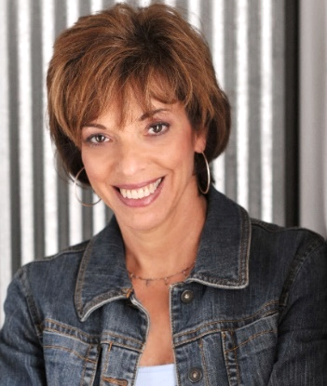 Living from the Heart LLC
SUE MCMAHON is a Professional Board-Certified Coach
& Founder of Living from the Heart LLC based in Northwestern Ohio, USA

For more than twenty years Sue has been privileged to partner with her clients in a thought-provoking and creative process that boldly challenges, inspires, and empowers individuals to courageously maximize their personal and professional potential. She thrives on the diversity of the human spirit and the unique beauty she sees in every human being. She is recognized by clients and colleagues as caring, energetic, intelligent, and intensely passionate. Her fierce desire to help others live a life shaped by personal choice comes from her recognition of humanity’s deep hunger for living a more truthful life.
The challenges Sue has experienced throughout her own life continue to be a driving force for her ongoing state of personal growth. She continually seeks to deepen her understanding of humankind through both learning and professional opportunities as a coach. Her desire to support the growth and evolution of the human consciousness is for the sake of creating a world more abundantly filled with love and compassion.
Fully committed to her profession as a coach, Sue aligns with the International Coaching Federation (ICF) as the global leader in professional coaching associations. As of April 2023, there were nearly 60,000 members in 169 countries and territories around the globe. She has been actively involved with the ICF since 2003, devoting a tremendous amount of time and energy to the promotion of professional integrity and ethical coaching practices, including her leadership of the ICF Independent Review Board and her current role as the Chair of the new ICF Ethics Advocacy Team. Sue is honored to have been inducted into the 2019 ICF Circle of Distinction as an experienced coach practitioner who has made her mark through significant contributions to the coaching profession and ICF over the course of her career.

Sue has been a registered nurse for her entire adult life, as well as a dedicated volunteer, serving various organizations and impacting countless lives with hours of service given to local community, national, and global efforts. Having been born and raised near East Lansing, Michigan, Sue eventually made Northwest Ohio her home. Her passion for coaching and ethics is second only to her greatest joy, that of spending time with her wonderful family and two Chocolate Labs, whether it is on an adventure or just hanging out. Loving the outdoors and nature, Sue finds every possible opportunity to hike the National Parks, ski the majestic mountains, or spend time at the ocean, or the beautiful waters of the surrounding Great Lakes.

